# Review of Yammer Search Function

Yammer is considering additional development work on their search function, and have requested a review of current search performance metrics to help evaluate how, or if, the function should be improved.

## Overall evaluation

The current function doesn’t appear to be widely used, and when used, doesn’t appear to guide users well. Any development effort should focus on improving the usability of search results.

## Incidence of search usage

Of the 9,760 users with events in the database, only 2,178 executed a search from the menu, or 22.3% (see appendix for database queries used to produce results). For a main feature, this seems to be a very low percentage.

## Selections of search results

In a well-designed search algorithm, the large majority of the search results actually executed should be in the first several results. The following is a graph of the distribution of the search results actually selected:

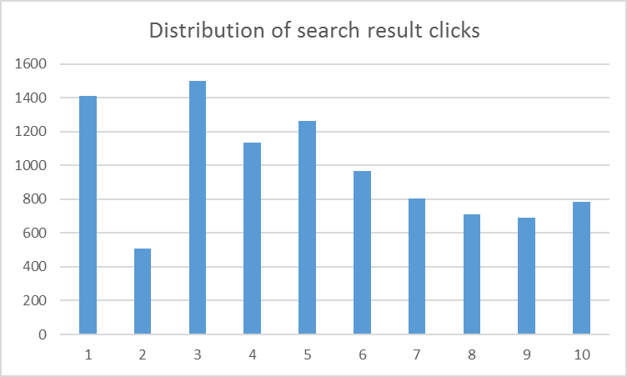

While the first and third options were the largest percentages selected, you would want a much more left-leaning graph of results selected.

## Data limitations

A manual review of the search events indicated that many searches run didn’t result in a result clicked, while others returned multiple selections. To be able to gauge the effectiveness of search results, data should be gathered that will relate the search result clicks against each individual search executed. This data could produce histograms that would indicate how many results pages were ignored entirely, how many resulted in one option selected, two, and so on. This would allow a much more accurate review of how users were acting on the search result page.

# Appendix – SQL queries used in data gathering

User search:

select count(distinct e.user_id) from tutorial.yammer_users u

, tutorial.yammer_events e

where u.user_id = e.user_id;

Users executing search:

select count(distinct e.user_id) from tutorial.yammer_users u

, tutorial.yammer_events e

where u.user_id = e.user_id;

Search events by user:

SELECT u.user_id, event_name, count(1) from tutorial.yammer_users u

left outer join tutorial.yammer_events e on u.user_id = e.user_id

where e.event_name like ('search%')

group by 1,2;